SWE20004 Technical Software Development Semester 1 2020

Assignment 1 report

Name: Dipesh Goyal Student ID:102558284

Lab class: Friday/2:30 Tutor: Srikanth Thudumu

Due Date: Friday 6th September 2019 at 11:59 pm

Date Submitted: Wednesday 29th August 2017 at 11:59pm

Assignment Title: 1

Program description

In your own words, describe what the application does or what
problem the application solves.
Remove the grey text and insert your content.

Inputs and Outputs
The inputs and outputs for this program are described in Table 1.

Table 1. Data dictionary:
Data to be stored | Sample data | Type of data | C++ type | Input method | In /  Out | Variable name
first name | “Fritz” | text: 2-20 characters | string | cin | cout | firstName
Interest amount | $1333.22 | real number | double | cin | out | amount

3. Algorithm
Program steps:
  - Flush the keyboard
  - Prompt for input
  - Enter the number
  - Check range – if too small or too big return to a.

Coding logic:
The equation and constants go here

Decoding logic:

You can represent algorithm as pseudocode or flowchart.

Source code:

Copy the code from visual studio or text editor you are using and paste it here

Screenshots showing working program (Show all possible outcome):

Paste in views of your program running in a msys, Mac or Linux command window
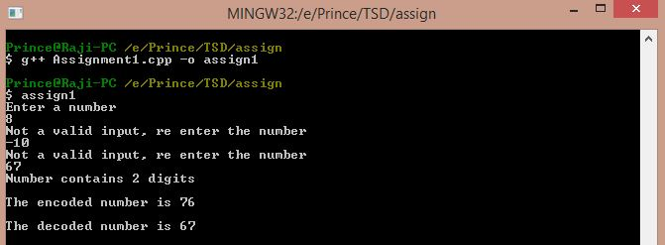

Task 2.11

Program description
This program calculates the voltage gain of an amplifier given the frequency and the stage of the amplifier. The cmath library is used to do the calculations in this program.

Source Code
- #include <iostream>
- #include <cmath>

- using namespace std;

- int main()
- {
- double x,y,voltage=0; // Variable Decalaration
- int stage = 0; // variable initialization
- cout<<"Enter the frequency: \n"; // User Prompts
- cin>> x; //storing frequency in variable x
- cout<<"Enter the stage of the amplifier: \n";
- cin>> stage; //storing stage in variable stage
- voltage = pow((275 / sqrt(pow(23,2) + 0.5 * pow(x,2))),stage); //Calculation
- cout<< "At a frequency of " << x <<" hertz, the voltage gain is " <<voltage; //Output
- return 0;
- }

Screenshots showing working program
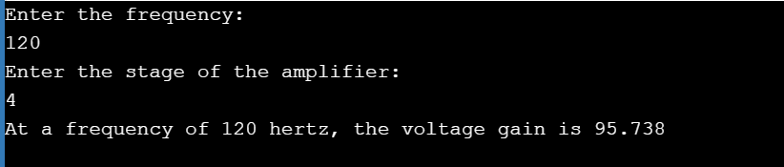

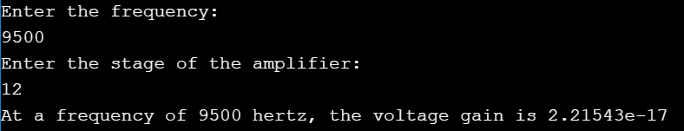

Task 3.8

Program description
This program prompts the user to enter data about a computer, username, employee name and IP. The IP is then stored as 4 different parts and used to calculate the IP in an integer form. The iomanip library is used to display the output in a formatted manner.

Source Code

#include <iostream>
#include <cmath> //calculations
#include <iomanip> // for setwidth function
#include <string> // For getline

/* This program produces a text-based form displaying data about a particular computer. */

using namespace std;

int main()
{
//Variable Declarations
string username, empname , mac, serialno;
char pctype;
double cpuspeed;
unsigned long long int IP = 0; // The integer data type wasn't big enough to store the ip so used long long.
int cores = 0;
unsigned int iP_part_1, iP_part_2, iP_part_3, iP_part_4 = 0;

// User Prompts
cout << " Please Enter The Username: ";
getline(cin, username);
cout << "\n Please Enter The Employee Name: ";
getline(cin, empname);
cout << "\n Please Enter The PC serial number(max 10): ";
cin >> serialno;
cout << "\n Please Enter The PC type (S=Server, D= Dekstop, L=Laptop, T=Tablet, P= Phone) : ";
cin >> pctype;
cout << "\n Please Enter The Number Of Cores: ";
cin >> cores;
cout << "\n Please Enter The CPU Speed (GHz) : ";
cin >> cpuspeed;
cout << "\n Please Enter The MAC Address : ";
cin >> mac;
cout << "\n Please Enter The IPV4 Address Without The Dots (e.g. 111 222 333 444) : "; // Stores ip in different variables
cin >> iP_part_1;
cin >> iP_part_2;
cin >> iP_part_3;
cin >> iP_part_4;

//Calculates IP
IP = iP_part_1 * pow(256., 3) + iP_part_2 * pow(256., 2) + iP_part_3 * 256 + iP_part_4;

//DISPLAY
// First Line
cout << "\n __________" << setw(67)
<< "+ \n";
cout << "| User: "
<< username << "|" << setw(10)
<< "Employee:" << setw(20)
<< empname << "|" << setw(8)
<< "Serial:" << setw(12)
<< serialno << setw(8)
<< "| \n";

// Second Line
cout << " __________" << setw(67)
<< "+ \n";

cout << "| Type: "
<< pctype << "|" << setw(7)
<< "Cores:" << setw(3)
<< cores << " |" << setw(5)
<< "Speed:" << setw(5)
<< cpuspeed << "Ghz "
<< "|" << setw(5)
<< "MAC:" << setw(10)
<< mac << " |" << setw(3)
<< " IP:" << setw(4)
<< iP_part_1 << "." << iP_part_2 << "." << iP_part_3 << "." << iP_part_4 << setw(4)
<< "| \n";

// Second Line
cout << " __________" << setw(67)
<< "+ \n";

// Third Line
cout << "|" << setw(40)
<< "IP Address as integer:" << setw(11)
<< IP << setw(26)
<< "| \n";

cout << setw(78) << "+ \n";

return 0;
}

Screenshots showing working program
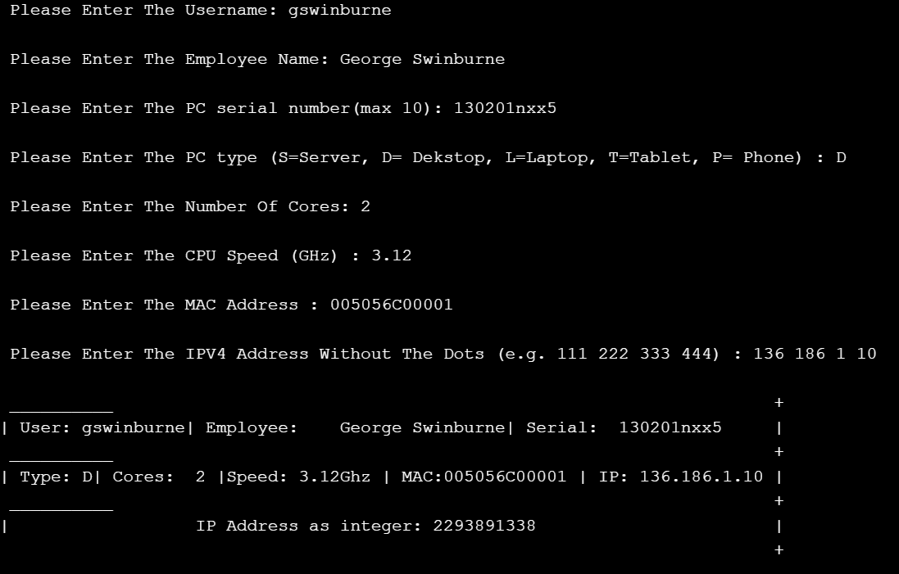

Task 4.9

Program description

This program takes the weekday as a number Sunday being 1 and Saturday 7. (these are taken in an integer and then passed through the switch statement. Same is done with weather 1-3 for sunny, cold and raining. The if statements are used to display the correct output depending on the combination of weather and weekday.

Source Code
- #include <iostream>

- using namespace std;

- int main()
- {
- // Variable Declarations
- int week;
- int weather;
- do
- {
- cout << "\nEnter week number (1-7):"; // User input for weekday.
- cin >> week;
- switch (week)
- {
- case 1: //Switch statement to display weekday output
- cout << "Sunday";
- break;
- case 2:
- cout << "Monday";
- break;
- case 3:
- cout << "Tuesday";
- break;
- case 4:
- cout << "Wednesday";
- break;
- case 5:
- cout << "Thursday";
- break;
- case 6:
- cout << "Friday";
- break;
- case 7:
- cout << "Saturday";
- break;
- default:
- cout << "\nInvalid Input! Please enter week in between 1-7.";
- }
- } while (week == 0 | week > 7); // Do while loop for invalid input
- do
- {
- cout << "\nHow's the weather today? (1)Sunny,(2)Cold or (3)Raining\n";
- cin >> weather;
- switch (weather)
- {
- case 1:
- cout << "Sunny"; //Switch statement to display weather output
- break;
- case 2:
- cout << "Cold";
- break;
- case 3:
- cout << "Raining";
- break;
- default:
- cout << "\nInvalid Input! Please enter week in between 1-3.";
- }
- } while (weather == 0 | weather > 3); // Do while loop for invalid input
- // OUTPUT STATEMENTS
- // If statements to display output
- if (week == 1 & weather == 1) //STARTING FROM SUNDAY.
- {
- cout << "\nEat Ice cream and go to the beach";
- }
- if (week == 1 & weather == 2)
- {
- cout << "\nStay home and watch a movie";
- }
- if (week == 1 & weather == 3)
- {
- cout << "\nCook soup and play a video game";
- }
- if (week == 2 & weather == 1)
- {
- cout << "\nYou walk.";
- }

- if (week == 2 & weather == 2)
- {
- cout << "\nYou take your jacket with you";
- }
- if (week == 2 & weather == 3)
- {
- cout << "\nYou take your Car.";
- }
- if (week == 3 & weather == 1)
- {
- cout << "\nYou walk.";
- }
- if (week == 3 & weather == 2)
- {
- cout << "\nYou take your jacket with you";
- }
- if (week == 3 & weather == 3)
- {
- cout << "\nYou take your Car.";
- }
- if (week == 4 & weather == 1)
- {
- cout << "\nYou walk.";
- }
- if (week == 4 & weather == 2)
- {
- cout << "\nYou take your jacket with you";
- }
- if (week == 4 & weather == 3)
- {
- cout << "\nYou take your Car.";
- }

- if (week == 5 & weather == 1)
- {
- cout << "\nYou walk.";
- }

- if (week == 5 & weather == 2)
- {
- cout << "\nYou take your jacket with you";
- }
- if (week == 5 & weather == 3)
- {
- cout << "\nYou take your Car.";
- }

- if (week == 6 & weather == 1)
- {
- cout << "\nYou walk..";
- }

- if (week == 6 & weather == 2)
- {
- cout << "\nYou take your jacket with you";
- }
- if (week == 6 & weather == 3)
- {
- cout << "\nYou take your Car.";
- }

- if (week == 7 & weather == 1)
- {
- cout << "\nEat Ice cream and go to the beach";
- }
- if (week == 7 & weather == 2)
- {
- cout << "\nStay home and watch a movie";
- }
- if (week == 7 & weather == 3)
- {
- cout << "\nCook soup and play a video game";
- }
- }

Screenshots showing working program
